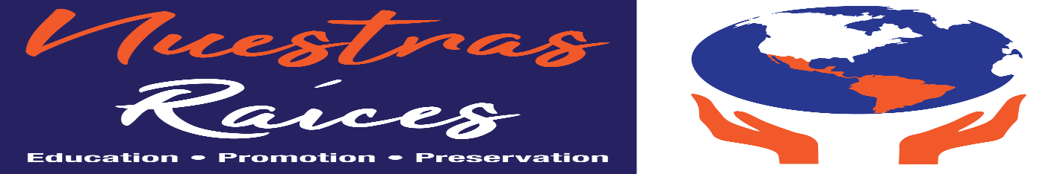
Parade of Latino Nations- Application Sunday, September 29, 2019 1:00 pm – 5:00 pm 4100 Eastern Ave, Baltimore. MD, 21224
GROUP NAME (UNIT, SCHOOL, ORGANIZATION, MARCHING BAND, COMMUNITY ASSOCIATION,) _________________________________________________________
Address: (street, city/state, zip) _______________________________________________________
Name: _____________________________________________________________________
Phone: _______________________email: __________________________________________
Expected number of participants: ______
Quantity of vehicles in the Parade:
Cars ________ Trucks ______Vans/SUV’s ______ Motorcycles _____ Other_______________
Detailed description of group: information needed for emcee's script at reviewing stand. _________________________________________________________________________________
_____________________________________________________________________________
_____________________________________________________________________________
Application submitted by:
Print Name: ________________________Date: ____ Signature: _________________________
Contact Person on the day of the Parade:
Print Name: _________________________________ Phone: ____________________________
Return Application via email... ASAP of before 08/31/2019
For additional information contact: Jesus Perez Email: perez.raices@gmail.com - Cell phone: 443477-1157

