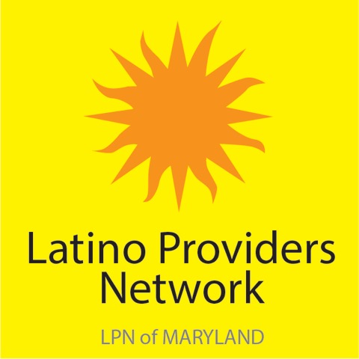

¡Celebrando Nuestra Comunidad! LPN Feria Latina 2019
!We Celebrate Our Community! LPN Latino Fair 2019
Saturday, May 4, 2019
10:00 AM - 2:00 PM
Sacred Heart of Jesus Church/Archbishop Borders School
601 S. Conkling St. Baltimore, MD 21224

Our vision for the 11th annual Feria Latina is to provide a quality event that celebrates the Latino community and its culture by delivering information and direct services to participants and providing an opportunity for our members to network with the community. There will be fun and engaging activities for all ages!

We are asking interested organizations to SUBMIT A PROPOSAL to participate.

The Feria Latina Planning Committee will select organizations that demonstrate one or more of the following:

1. Provide an ENGAGING activity or direct service.
2. Provide something FUN & ENGAGING for children, families, or adults.
3. Share information about your organization in a NEW & ENGAGING manner
(games, craft, service and activities).

All selected Feria service providers will be expected to:

1. Meet deadlines and due dates for needed items (3/31/2019).
2. Set up time: 9:00 a.m. the day of the event (Sat. May 4). *Please bring
a tent if your organization will need one.
3. Bring MINIMAL paper material from your organization. * Please note that
access to electrical/power outlets will NOT be available.
4. Provide a Spanish-speaking representative/bilingual staff at the event.
5. Commit to stay for the full event: 10:00am to 2:00pm.

Feria Latina service providers will:

1. Receive FREE lunch the day of the event.
2. Be provided one table with two chairs.

QUESTIONS?
Email contact@lpnmd.org
Partner PROPOSAL FORM
DUE: SUNDAY, March 31, 2019
By email: contact@lpnmd.org
_______
Organization:
LPN Member: ___Yes ___No [Note: there is a $100.00 vendor fee for non-members.]
Contact Name:

Email:

Address:

Phone:

Please select which area of the festival your organization would fall under:
____ FAMILY [Housing, Employment, Domestic Violence]
____ HEALTH [Mental, Behavioral, Physical, etc.]
____ IMMIGRANT & LEGAL SERVICES [Safety, Law, Crime, Family Preparation, Police, Fire]
____ EDUCATION/ARTS/CULTURE [Education, Arts, Culture, Literary Arts]

Please let us know if you will need a tent. We will have a LIMITED number of tents available on a first come first serve basis.

Yes, I need a tent _____
No, I will bring my own tent OR I don’t need a tent _____

Proposal: In 100 words or less, please describe what activity or direct service you will provide.
Please refer to our vision and the goals listed on the reverse side.

*Any proposals received after the DUE DATE will not be considered.

Completing and returning this form DOES NOT guarantee your space at the Feria.

¡Celebrando Nuestra Comunidad! LPN Feria Latina 2019

If you and/or your organization are not a member of the Latino Providers Network, Inc.,
there is a $100.00 vendor fee to participate in the Feria Latina 2019.

Organization: ___________________________________________

Contact name: __________________________________________

Please complete this coupon and mail with your check made payable to Latino Providers Network, Inc.
Latino Providers Network, Inc.
3121 Eastern Ave
Baltimore, MD 21224

